MGMT-1224 – Annotated Bibliography, Research Report and Presentation – 30% of final grade

This **group** assignment includes 3 parts:

1. An APA-formatted annotated bibliography (10% of your final grade in the course)
2. A double-spaced, four- or five-page report (10% of your final grade in the course)
3. A 5-minute **formal** presentation (10% of your final grade in the course) - delivered to classmates with ***a PDF or printed handout*** for your classmates.

**Learning outcomes:**

Students who complete this assignment have demonstrated their ability to:

a) conduct a literature search in the field of business administration,

b) select authoritative, accurate and relevant sources,

c) read trade, professional and/or scholarly information and identify key points,

d) write an annotated bibliography,

e) write a report and

f) prepare and deliver a business presentation to a board.

**Scenario:**

*Your CEO (JB!) has asked you, the new IT specialist, to deliver an* ***engaging*** *and* ***informative presentation*** *to* ***new board members*** *about a topic of importance to the organization. In order to ensure your presentation is based on authoritative, accurate and relevant research, you decide to conduct a* ***literature search****, compile an annotated bibliography, then write a 4 or 5 page, double-spaced report that you will submit to JB as evidence of your subject matter knowledge. Then you plan to prepare a 5-minute presentation for board members that highlights key points of interest from your research report. It will NOT include every, single, detail from the research report!* ***JB says that board members expect presenters to provide them with a handout that summarizes the key points in the presentation****, so you will also prepare a handout.*

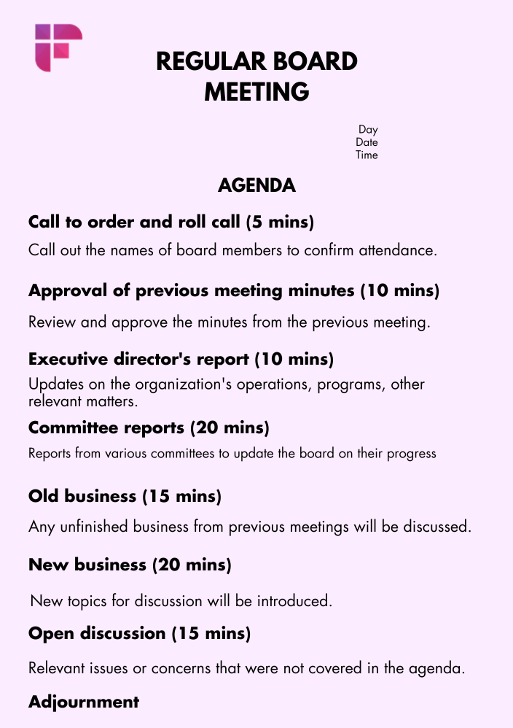[8 Free Board Meeting Agenda Templates | Fireflies.ai](https://fireflies.ai/blog/board-meeting-agenda-template)

**Steps to Completion**

Step 1: Choose and highlight a topic from the following list.

1. *What are some* ***best practices or new trends in conducting the strategic planning process in a business****?* Investigate **ONE** aspect of strategic planning in more depth than we did in class in week2. For example, you could learn more about conducting a SWOT or alternatives to SWOT, gathering stakeholder input, or communicating the plan.
2. *What are some* ***best practices or new trends in using social media to market a business****?*
3. Choose **one provincial or federal government privacy act**. *What are some of the* ***challenges, cautions, and/or rules about operating a business within the framework of the privacy act*** *you selected?* Consider focusing your research on the impact to your field placement organization or other specific business (eg. Facebook, Google).
4. *What are some of the* ***best practices in orienting and training new employees****?*
5. *What are some of the* ***actions organization can take to demonstrate they value equity, diversity and inclusivity in the workplace****?*
6. *What are some* ***best practices and strategies policy-makers can use to ensure business policies and procedures are bias-free and inclusive****?*
7. *What are some* ***trends in cybersecurity****, such as zero trust architecture, AI and machine learning in threat detection, and the importance of cybersecurity hygiene. Investigate* ***one*** *aspect in depth, like ransomware defense strategies or the role of employee training in preventing breaches.*
8. *What are the* ***trends in AI/ML****? How are AI and machine learning algorithms being integrated into business processes to enhance decision-making, improve efficiency, and drive innovation. Focus on* ***one*** *industry &* ***one*** *specific application, such as predictive analytics in sales forecasting or AI in customer service.*
9. *What are the* ***IT job market trends****? How is the rapid evolution of technology shaping the future of IT roles and the skills needed to thrive in the corporate IT world. Delve into* ***one*** *topic such as the rise of the Chief Data Officer – or Chief AI Officer -- or the increasing importance of* ***soft skills*** *in tech roles.*

Step 2: Conduct a literature search to learn more about your topic.

Use a tool like [Google Scholar](https://scholar.google.com/) (be sure to click *settings, library links* and input Durham College Library), search a specific publication like [Harvard Business Review](https://login.dproxy.library.dc-uoit.ca/login?qurl=https%3a%2f%2fsearch.ebscohost.com%2fdirect.asp%3fdb%3dbth%26jn%3dHBR%26scope%3dsite), do a general Google search of professional association or business websites, search the DC Library using the [*advanced search*](https://ocul-it.primo.exlibrisgroup.com/discovery/search?vid=01OCUL_IT:DURHAM&lang=en&mode=advanced)interface, and/or search Lynda.com for workshops…to find accurate, authoritative, relevant information about your topic. Complete the [CRAAP test](https://drive.google.com/file/d/1M8rX3XnCcDWODOl16cmRpy2Dh97dD-JB/view?usp=sharing) to learn strategies to use when evaluating information sources.

Step 3: Prepare an annotated bibliography

Prepare it with 4 or more information sources you found when you conducted your literature search. Use the examples on the annotated bibliography template (below) when writing your annotated bibliography.

Step 4: Double Spacing!

Write a *write a 4-5page, double-spaced* report that answers the research topic question. Use the instructions on the assignment template (below) when writing your report. Please cite the authors whose ideas you use in two places: firstly, within the text of your report AND secondly, on a separate References page. *Note that the References page is not part of the 2-page double-spaced report.*

Step 5: Create a Presentation & Agenda

Create a short presentation for Board members as well as a handout (either in PDF or physical) that identifies the key points from the presentation. Use the instructions on following pages when creating your presentation.

Annotated Bibliography Template (10 marks)

<insert the question you selected in Step 1>

Beadle-Brown, J., Hutchinson, A., & Whelton, B. (2017). <insert APA-formatted citation for source>

How I decided this source passes the CRAAP test: *HINT: Complete the* [*CRAAP test*](https://drive.google.com/file/d/1M8rX3XnCcDWODOl16cmRpy2Dh97dD-JB/view?usp=sharing) *to learn more about evaluating information sources.*

<*CPAs – provide proof or an explanation of how you verified this source was worthy to use in your report*> (**1.25 marks**) ~ for example ~ This article is *accurate*. I found similar information in a book from the Campus Library, a magazine for business administrators, and in Harvard Business Review, a journal recommended by JB. It is also *relevant*, because it discusses the impact of inclusive and diverse policies in a business in Ontario, which is useful to me as I plan to work in Ontario when I graduate, so the examples and impacts may be the same in my (future) workplace. I believe the author is *authoritative* <*CPAs – provide proof or an explanation of how you decided the author is authoritative*.> because I searched his name in Google Scholar and see that he’s written several articles on this topic that have been published in scholarly (journal) publications, and I Googled his name and found that he works at <big name> university and is listed on their Faculty of Business webpage as a professor.

What I learned from this source:

*<insert details about what you learned in this source that helps you answer the question you chose in Step 1>* (**1.25 marks**)

McConkey, R. (2020). <insert APA-formatted citation for source>

How I decided this source passes the CRAAP test:

*<insert details about how you verified this source was worthy to use in your report>*

What I learned from this source:

*<insert details about what you learned in this source that helps you answer the question you chose in Step 1>*

Morrissey, P. A., Franzini, L. R., & Karen, R. L. (2015). <insert APA-formatted citation>

How I decided this source passes the CRAAP test:

*<insert details about how you verified this source was worthy to use in your report>*

What I learned from this source:

*<insert details about what you learned in this source that helps you answer the question you chose in Step 1>*

Another Source <insert APA-formatted citation>

How I decided this source passes the CRAAP test:

*<insert details about how you verified this source was worthy to use in your report>*

What I learned from this source:

*<insert details about what you learned in this source that helps you answer the question you chose in Step 1>*

NOTE: You might end up using several more sources in your research assignment, and that’s fine. For the purposes of this assignment, I am grading four of your choices only for authority, relevance and accuracy, and for your ability to identify key points from the source as they relate to the question you selected in Step 1.

Report Template (your report should use 4 or 5 pages and should be double-spaced) (10 marks)

Date: TBA

To: JB Abbas

From: <your name>

Subject: <topic of your report> Research Report and Annotated Bibliography for MNGT 1224

CPAs – the following report is meant to guide you as you write your report. Please delete the sample words in italics that I inserted and replace them with your own sentences.

Here is the report that you requested on January 24th, 2023. It answers the question, *“<insert the question you chose to answer from Step 1 of the assignment.>”*

Best Practices (CPA students – use headings that reflect your research question and topic)

*A search of the professional literature indicates that there are several ways to conduct an analysis of the external and internal environment in which the business operates. Morrissey, Franzini, & Karen, (2015) found that <insert research findings that describe one method of conducting an analysis …> They note that <insert more key ideas from these researchers.> This method is also recommended in articles by <insert the names of the authors of the other articles that recommend this method.> Clearly, this is a trusted and well-recommended method..*

*Another method involves <insert what the other method involves> McConkey (2020) advocates for using this method because ... He notes that <insert research findings that describe another method ….>*

*Some authors <cite the authors!> recommend smaller organization… <insert research about other methods …>*

Conflicting or Contradictory Information (CPA students – use headings that reflect your research question and topic)

*While most authors surveyed recommended…two authors advised against…. <cite!>*

Trends (CPA students – use headings that reflect your research question and topic)

*A careful review of the literature over the past 15 years reveals that many businesses are moving away from….*

*Another trend discussed in several recent articles is…<insert trend, and cite the authors!>*

Conclusions and Recommendations (CPA students – use headings that reflect your research question and topic)

*Most authors recommend organizations ensure the evaluation used in the strategic planning process…*

References

(your References page is a separate page, not included in the two pages of your report)

APA formatted citation for any source cited in-text in the report. (HINT: you can copy and paste the APA citation from your Annotated Bibliography page!)

APA formatted citation for any source cited in-text in the report.

APA formatted citation for any source cited in-text in the report.

APA formatted citation for any source cited in-text in the report.

See the Durham College Library APA Citation Style guide for instructions on how to format in-text citations and References page citations. <https://www.durhamcollege.ca/wp-content/uploads/apa.pdf>

NOTE: I realize this page is somewhat redundant since you are submitting an annotated bibliography.

Presentation Instructions

In your **presentation** to the board (your classmates will play the role of the board), include the following information:

1. An agenda and introduction (with a hook – see week 3 slides for a definition and example of a *hook*) (30 seconds - 1 minute)
2. A *few* details about the key points from your research report (2 minutes)
3. A conclusion restating the key points (with a reference to the introductory hook) (1 minute)
4. An offer to answer any questions from the board (1 minute)

DO NOT re-state the detailed, in-depth research from your 2-page report in your presentation. Your presentation should be brief, engaging, and contain interesting facts or key take-aways from your research.

Please also prepare a **handout** for the board (your classmates) that identifies and summarizes the key points from your presentation.

Annotated Bibliography, Research Report and Presentation Rubric

|  |  |  |  |  |
| --- | --- | --- | --- | --- |
|  | Level One | Level Two | Level Three | Level Four |
| Written Communication Skills  (4 marks)  grammar, spelling, organization (headings, transition sentences and appropriate tone), APA citation style | Missing, incomplete (0-2 marks) | Sometimes and with some competence …uses the writing process to write an annotated bibliography and report that show some organization of information (1 mark). Sources are sometimes documented (bibliography, in-text citations and References citations) (1 mark) | Usually and with competence… uses the writing process to write an annotated bibliography and report that show an acceptable level of organization of information (1.5 marks). Sources are usually carefully and accurately documented (bibliography, in-text citations and References citations) (1.5 marks) | Always and with a high degree of competence and skill…uses the writing process to write an annotated bibliography and report that show a high degree of organization of information (2 marks**)**. Sources are always carefully and accurately documented (bibliography, in-text citations and References citations) (2 marks) |
| Verbal Communication Skills, Presentation Skills  (8 marks)  (HINT: read the LOVRICK chapter excerpt on reserve at the library, linked in week 3 slides) | Missing, incomplete (0-2 marks) | Sometimes and with some competence… incorporates the incorporates presentation skills strategies and techniques to deliver an organized, engaging, professional, informative presentation (eg. tone of voice, pacing, non-verbal communication, professional appearance, effective slides, audience engagement) (4-5 marks) | Usually and with competence… incorporates presentation skills strategies and techniques to deliver an organized, engaging, professional, informative presentation (eg. tone of voice, pacing, non-verbal communication, professional appearance, effective slides, audience engagement)  (6 marks) | Always and with a high degree of competence and skill… incorporates presentation skills strategies and techniques to deliver an organized, engaging, professional, informative presentation (eg. tone of voice, pacing, non-verbal communication, professional appearance, effective slides, audience engagement)  (7-8 marks) |
| Knowledge  (18 marks)  choose appropriate sources, explain how you determined they were credible, identify key facts from the source that help answer the research question;  write a report that answers the research question, with appropriate breadth and depth for a 3rd year college course | Missing, incomplete (0- marks) | Sometimes and with some competence…  1. Compiles a bibliography of sources that are authoritative, accurate and relevant to answering the question (2-2.5 marks)  2. Annotates a bibliography of sources and identifies key information to answer the question selected in Step 1  (2-2.5 marks)  3. Uses the report template provided to write a report that answers the question selected in Step 1 - clearly, thoroughly and with sufficient and appropriate depth and evidence from the literature (4-4.5 marks)  4. Creates a handout that summarizes evidence to answer the question selected in Step 1 (1 mark) | Usually and with competence…  1. Compiles a bibliography of sources that are authoritative, accurate and relevant to answering the question (3 marks)  2. Annotates a bibliography of sources and identifies key information to answer the question selected in Step 1 (3 marks)  3. Uses the report template provided to write a report that answers the question selected in Step 1 - clearly, thoroughly and with sufficient and appropriate depth and evidence from the literature (5 marks)  4. Creates a handout that summarizes evidence to answer question selected in Step 1 (1.5 marks) | Always and with a high degree of competence and skill…  1. Compiles a bibliography of sources that are authoritative, accurate and relevant to answering the question (4 marks)  2. Annotates a bibliography of sources and identifies key information to answer the question selected in Step 1 (4 marks)  3. Uses the report template provided to write a report that answers the question selected in Step 1 - clearly, thoroughly and with sufficient and appropriate depth and evidence from the literature (6-8 marks)  4. Creates a handout that summarizes evidence to answer the question selected in Step 1 (2 marks) |